In-Depth Research Report on:- Subdomain Takeover and Broken Link Hijacking

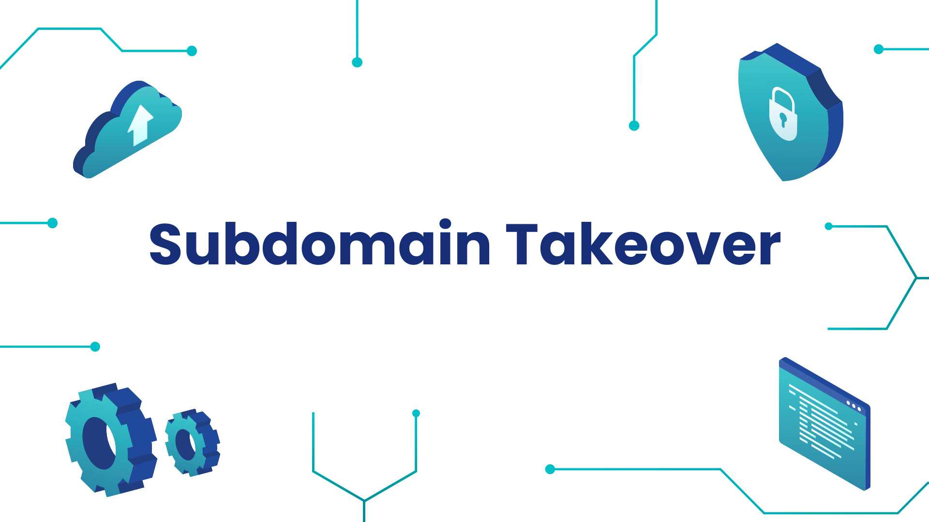

1. Introduction
Subdomain takeover and broken link hijacking (BLH) are significant security vulnerabilities that can lead to unauthorized access and malicious exploitation. This report explores the concepts, impacts, mitigation strategies, and tools associated with both threats.
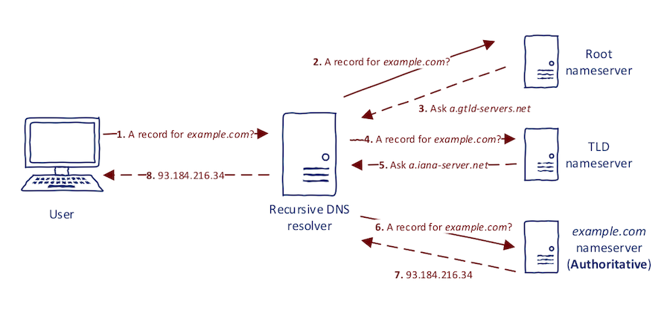

2. Subdomain Takeover

2.1 What is a Subdomain?
A subdomain is a subset of a domain name that can be used to organize and navigate different sections of a website. For example, in the domain "example.com," "blog.example.com" and "shop.example.com" are subdomains.

2.2 What is Subdomain Takeover?
Subdomain takeover occurs when an attacker claims a subdomain that is improperly configured or has been abandoned. This typically happens when the original service linked to the subdomain is deleted or misconfigured, allowing an attacker to create a new service (often malicious) on that subdomain.

2.3 Subdomain Takeover Tools
Several tools can help identify vulnerable subdomains and automate the takeover process, including:
- Subjack: A tool designed to identify subdomain takeover vulnerabilities.
- Subdomain Takeover Scanner (SUT): Scans for potential takeovers by checking for DNS entries pointing to non-existent services.
- Assetfinder: Gathers subdomains and can help in identifying those vulnerable to takeover.
- Amass: A tool for reconnaissance that can help discover subdomains and check their status.
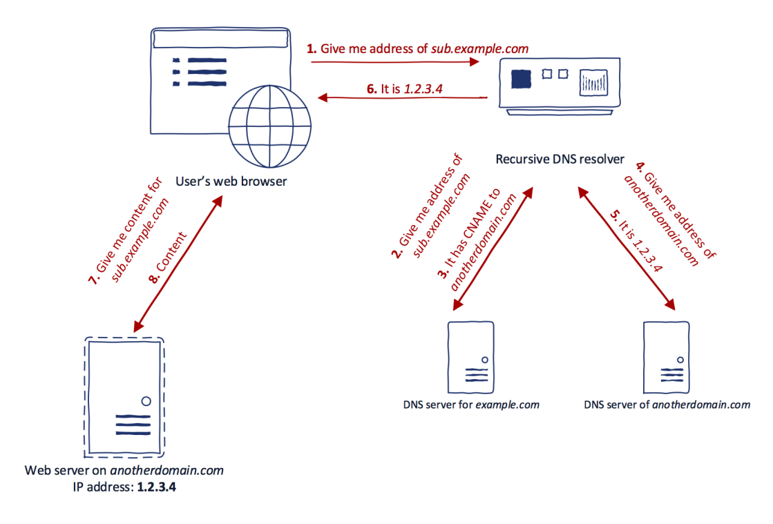

2.4 Impacts of Subdomain Takeover
- Data Breach: Attackers can gain access to sensitive information.
- Brand Reputation Damage: Malicious content on the subdomain can harm the organization's reputation.
- Phishing Attacks: Attackers can host phishing pages to trick users into revealing credentials.
- Loss of Control: Organizations lose control over their subdomain, which can be exploited for various attacks.

2.5 Mitigation Measures
- Regular Audits: Conducting regular audits of DNS records and subdomains to identify inactive or misconfigured entries.
- DNS Management: Properly managing DNS records and promptly removing subdomains that are no longer in use.
- Service Monitoring: Implementing monitoring to detect unexpected changes to subdomain configurations.
- Use of CNAME Records: Where appropriate, use CNAME records that point to active services to prevent orphaned subdomains.

3. Broken Link Hijacking (BLH)

3.1 What is Broken Link Hijacking?
Broken Link Hijacking occurs when an attacker takes advantage of broken links on a website. When a link points to a non-existent resource (e.g., a deleted page), the attacker can register the domain or subdomain that the link points to and redirect users to malicious content.

3.2 How to Use BLH
- Identifying Broken Links: Use tools like Google Search Console, Screaming Frog, or Broken Link Checker to identify links pointing to non-existent resources.
- Registering Domains: If a broken link points to a deleted domain, an attacker can register that domain and host content on it.
- Redirecting Traffic: The attacker can then redirect traffic from the broken link to malicious sites, phishing pages, or other harmful content.

3.3 Impact of Broken Link Hijacking
- Phishing: Users may be redirected to phishing sites designed to steal credentials.
- Malware Distribution: Attackers can host malware on hijacked domains.
- Reputation Damage: The organization may suffer reputational harm if users associate it with malicious content.
- Loss of Trust: Users may lose trust in the organization, leading to decreased engagement.

3.4 Mitigation Measures
- Regular Link Audits: Conduct periodic checks of all links on the website to identify and fix broken links.
- 404 Handling: Properly configure 404 error pages to guide users rather than leave them at a dead end.
- Monitor Domain Expiration: Keep track of domains associated with your brand and ensure they are renewed.
- Implement Security Headers: Use security headers to prevent unauthorized content from being served on hijacked domains.

4. Conclusion
Both subdomain takeover and broken link hijacking pose serious risks to web security. Organizations must implement robust mitigation strategies, conduct regular audits, and employ tools to protect against these vulnerabilities.

5. References
- Kaur, P., & Agarwal, R. (2020). "Understanding Subdomain Takeover Attacks." Journal of Cybersecurity and Privacy.
- Sood, A. K., & Singh, K. (2021). "Broken Link Hijacking: A New Threat Vector." IEEE Security & Privacy.
- OWASP Foundation. (2023). "OWASP Top Ten Project: Security Risks." OWASP.
- Gupta, R., & Kaur, J. (2019). "Exploiting DNS Vulnerabilities: A Case Study on Subdomain Takeover." International Journal of Information Security.
- "The Impact of Broken Links on SEO." (2022). Search Engine Journal.

